RISK MANAGEMENT & INSURANCE
University of Calgary
october 1, 2023
VRMS Handbook
for Better Impact Administrators

Table of Contents
Introduction to the Volunteer Registration and Management System (VRMS) 1
Coordinator Resources: 1
System Support: 1
VRMS - Getting Started 2
Better Impact (BI) Account Set-Up 2
Minimum Legislative Requirements in Better Impact 3
Connecting volunteer applicants to your Better Impact application forms: 4
Generating links to Application Forms from the Links for Website page: 5
Generating links to Application Forms from the Application Form Settings page: 5
Approving Applicants and Updating Volunteers’ Status 9
Approving New Applicants: 9
Updating Volunteers’ Status 11
Creating Application Forms in Better Impact 13
Sections for Dept Coordinator to edit/update: 13
Creating Activities in Better Impact 16
Create an Activity – Directions 18
Occupational Health and Safety Requirements 20
Occupational Health and Safety and Better Impact 20
Volunteer Hazard Assessment 21
Volunteer OHS Orientation Process 2021 22
Steps for Coordinators: 22
OHS Completions: 23
Checking for prior completions of the OHS training 23
Volunteer Hours: Logging, Approving, Reporting 24
Logging Hours 24
Approving Hours 24
Hours Reporting 24
Managing UC Volunteers – Legislative Components in Better Impact 25
Definition of a University of Calgary Volunteer 25
Occupational Health and Safety (OHS) 25
Workers Compensation (WCB) 25
Freedom of Information and Protection of Privacy Act (FOIP) 25
Legal Liability Compliance 26
Human Resources 26
VRMS Administrators’ Roles and Responsibilities 27
Enterprise: 27
Department (Organization) Account: 27

Introduction to the Volunteer Registration and Management System (VRMS)

To meet requirements, legislative elements are presented within the software or included through process – some are controlled by the Enterprise (overarching UCalgary account), while others must be managed by coordinators at the department level. Directions necessary to meet compliance when using volunteers to support UCalgary’s programs and events are provided in the following pages.
- Training is available through various sources. See below for types of training and available supports.
- Each Better Impact account requires a minimum of one, preferably two, Dept Coordinator(s) who will serve as the primary contact between the Enterprise (Risk Management & Insurance department) and the department. They are responsible for ensuring that anyone in their department that is using volunteers are made aware of, and are adhering to, legislative requirements. For specific responsibilities of the administrative roles, please see VRMS Administrators’ Roles and Responsibilities.
- The information contained here is targeted towards Dept Coordinators and should be passed along to Volunteer Coordinators, as applicable. See VRMS Administrators’ Roles and Responsibilities
- When the Better Impact account was allocated to your department, some elements were pre-entered and should not be changed. Before working in your account, review the page Minimum Legislative Requirements in Better Impact to become familiar with these elements, and to ensure you are processing your volunteer registrations in accordance with legislation.
- For details about legislation governing volunteer management, refer to: Managing UC Volunteers – Legislative Components in Better Impact

Coordinator Resources:
- VRMS Handbook
- Risk Management & Insurance website Volunteer Registration & Management pages

System Support:
- UC Enterprise Administrators:
  - ucvolunt@ucalgary.ca
- Better Impact Help (administrators):
  - https://www.betterimpact.com/volunteerimpacthelp/
- myImpactPage.com Help (volunteers):
  - https://www.betterimpact.com/siteguide/

VRMS - Getting Started

Better Impact (BI) Account Set-Up
To increase your success using the Better Impact system, planning is key. It is important to take the time to consider how your department is structured and how you would like it to be presented in the Better Impact system.
You might consider the following:
- The type of programs/events you offer
- The specific types of tasks/roles that would be required to fulfill the needs of the programs/events
- Prerequisites to perform, or be assigned to, a particular task or role.
- Type of information needed to pre-screen the majority of your applicants
- The level of automation you want when scheduling opportunities, sign-ups, etc.
- The kind of data/reporting you will need about your programs/volunteer types

Administrator access to Better Impact: https://app.betterimpact.com/Login/Admin

- Identify Department (Dept) and/or Volunteer Coordinators – See VRMS Administrators’ Roles and Responsibilities
  - Obtain a signed Oath of Confidentiality for each Dept and Volunteer Coordinator (VC) you wish to have admin access on your Better Impact account
  - Advise all Department and Volunteer Coordinators to take the Volunteer Coordinator OHS Orientation training (Course ID -1327) in Enterprise Learning
  - To add Dept or Volunteer Coordinators to the Better Impact account, contact the Enterprise Administrator at ucvolunt@ucalgary.ca. Include with your request:
    - Signed Oath of Confidentiality – this should be signed by the coordinator requiring access and their supervisor (form is available on the Risk Management & Insurance website and the Enterprise Document Library in Better Impact).
    - Volunteer Coordinator OHS Orientation Certificate of Completion
** Coordinators will not be added to the Better Impact account without these accompanying documents
  - Arrange for all Department and Volunteer Coordinators to review this handbook.
- Add account Contact information (dept/program address, email, phone, website URL, etc.)
  - Go to:
    - Configuration ( icon)
    - Organization Settings
    - Contact information
  - Optional: Add program Mission Statement and/or Social Media links
- Create Applications (default application) as directed in the document: Creating Applications in Better Impact
- Create Activities as directed in the document: Create an Activity
- Include a link to connect your applicants to your application forms on your recruiting interface (see Better Impact instructions Links for Website and Email)

Minimum Volunteers’ Legislative Requirements in Better Impact

IMPORTANT: No applicant should be moved to an ACCEPTED status and assigned to volunteer before fulfilling the following requirements:
Potential volunteers must APPLY through the Better Impact system to legally agree to our waiver and age requirements. See Manual Entry Process if volunteer cannot submit the application themselves.
- Agree to the liability waiver – presented in two places
  - To new applicants at the myImpactPage login screen:
    - Agreement to the terms of the waiver is required to proceed with the application form AND
  - As a statement (custom field) on new application forms.
    - This is included by the Enterprise as a requirement of acceptance and cannot be changed or removed from the application forms.
    - Application submission will be rejected by the system if applicant does not accept the waiver terms.
- Applicants must attest to being 18 years of age or older as presented in the custom field “Are you age 18 or older?”
    - This is included by the Enterprise as a requirement of acceptance and cannot be changed or removed from the application forms.
    - Application submission will be rejected by the system if applicant does not attest to being age 18+
  - Applicants under age 18 CANNOT apply through Better Impact
    - Contact ucvolunt@ucalgary.ca for more information about managing volunteers who are not yet age 18.
**Step-by-step instructions for approving/accepting a volunteer are below - see Approving Applicants
- Complete the OHS Orientation.v2021
  - For directions on how to communicate this to your volunteers, and to verify the course has been completed, refer to the page Volunteer OHS Orientation Process 2021
    - NO new or existing volunteers should be permitted to volunteer without confirming this training has been completed.
- Privacy Policy must be displayed on the application forms. Please refer to the page Creating Application Forms for its placement – this may be pre-filled, so do not change if it already matches what is contained in these directions.
- Prepared Hazard Assessments should be made available for review on Better Impact if using the self-scheduling feature for activities. Please refer to the page Creating Activities in Better Impact
- Logging Volunteers’ Hours should be done regularly, preferably as performed. They can be logged by either the volunteer, or by the coordinator, but must be coordinator-approved. See the page Volunteer Hours: Logging, Approving, Reporting

Connecting volunteer applicants to your Better Impact application forms:

For a potential volunteer to be managed in your Better Impact account AND have access to YOUR volunteer opportunities from the volunteer portal (myImpactPage.com), they need to complete and submit an online application form.
As the University of Calgary volunteer opportunities are not generally publicly accessible, YOU must provide new applicants with a link to your application form(s) either as:
- a link on your website (recruitment platform), OR
- an email invitation, OR
- any other electronic communication method you are using (i.e., text, social media, etc.)
  - Steps to GENERATE LINKS to application forms are detailed here Generating Links to Application Forms

- Once an applicant submits the application, they:
  - will have access to Better Impact’s myImpactPage.com volunteer portal
    - they CANNOT access the volunteer portal (myImpactPage.com) without creating a Better Impact login, which is part of the application process
  - can be managed in your Better Impact account
    - they CANNOT access your volunteer opportunities without submitting an online application form specifically to YOUR department/program
The process workflow is:
- Potential applicant is provided with a link to the department’s application form;
- the link opens the Better Impact volunteer login page;
- the applicant will either create a new login OR sign in (if they have volunteered with other organizations that use Better Impact, they can use the same login);
- the application form displays
- the applicant completes the form and selects “submit”
  - a pop-up confirms the application has been submitted
  - a “New Applicant” email is auto-generated as per settings previously determined
  - the Better Impact coordinator(s) is alerted to the new application
- the volunteer coordinator:
  - ensures requirements are met, approves the application, and notifies the volunteer
- now the volunteer can see your account and relevant opportunities on myImpactPage.com, as applicable

**Refer to the following pages for step-by-step instructions and their respective screenshots for generating links to your application forms.

Generating links to Application Forms from the Links for Website page:
- Go to: Configuration – icon (Fig. 1a)
- Click on “Links for Website” found in the sidebar under Recruitment
- Choose the: (Fig. 1b)
  - Application Form: Direct link to your application form, OR
  - Mobile Application Form: Direct link to your mobile application form
- Select the application form to generate – typically, Volunteer 1 form
- Click Generate Link (green button lower right of page)

OR:

Generating links to Application Forms from the Application Form Settings page:
- Go to: Configuration – icon (Fig. 2)
- Click on “Application Form Settings” found in the sidebar under Recruitment
- Select the application form to generate – typically, Volunteer 1 form
- Click Generate Link (green button top or bottom of page)
Note: When a volunteer clicks on your application form link, they can create a new profile (“I am new to MyImpactPage.com”) or re-use an existing profile (“I already have a username”).

For other Better Impact how-to articles and video demonstrations go to: https://support.betterimpact.com/volunteerimpacthelp/en/help-articles/ OR search from your Better Impact account using the Help (?) icon in the search bar at top right corner of the page

Fig. 1a - Generating links to application forms from the Links for Website page:

- Go to: Configuration
- Click on “Links for Website” found in the sidebar under Recruitment

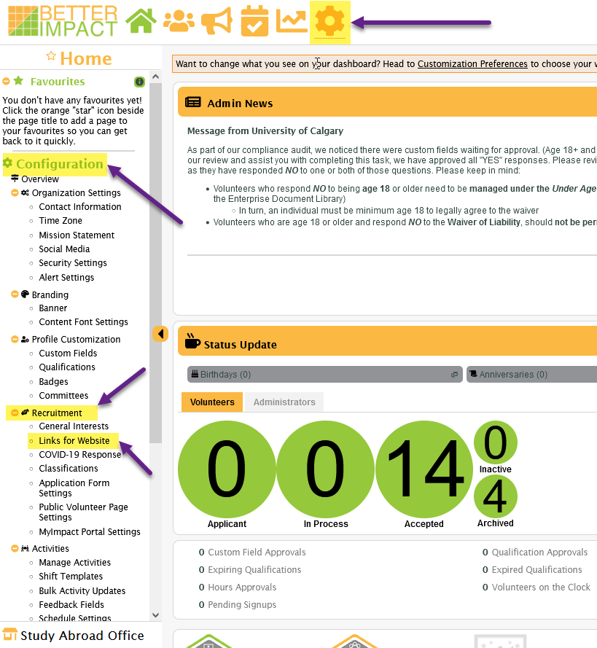

Fig. 1b - Links for Website page selections:

- Choose the:
  - Application Form: Direct link to your application form, OR
  - Mobile Application Form: Direct link to your mobile application form
- Select the application form to generate – typically, Volunteer 1 form
- Click Generate Link (green button lower right of page)

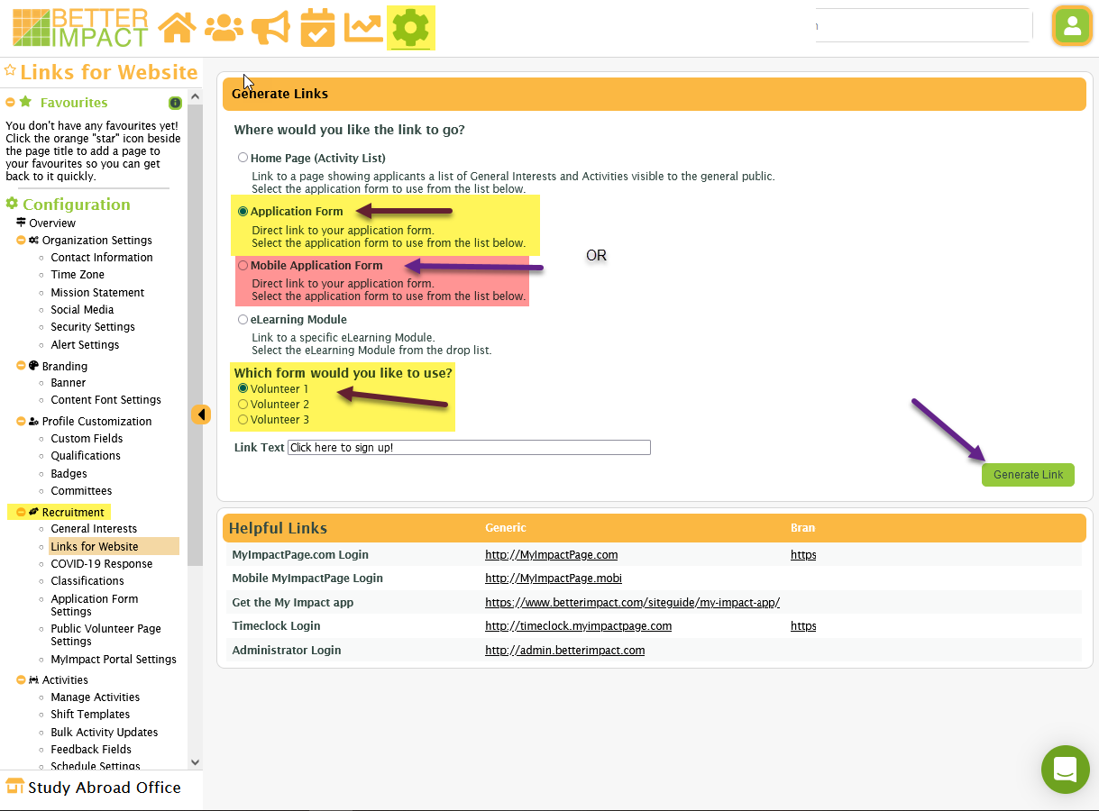

Fig. 2 - Generating links to application forms from the Application Form Settings:

- Go to: Configuration – icon
- Click on “Application Form Settings” - found in the sidebar under Recruitment
- Select the application form to generate – typically, Volunteer 1 form
- Click Generate Link (green button top or bottom of page)

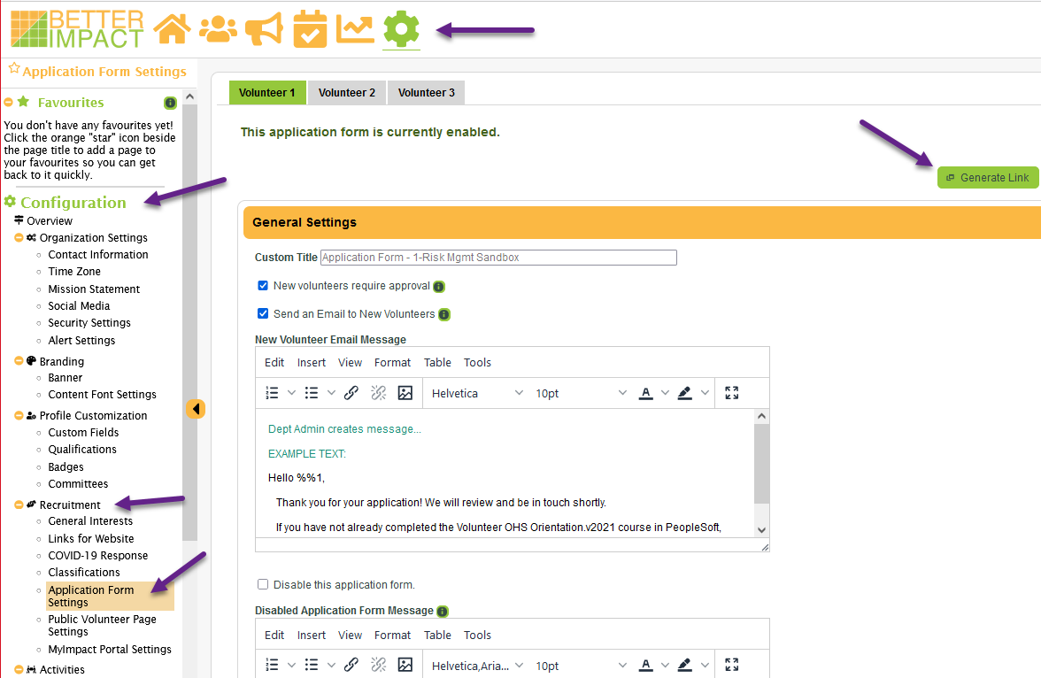

Approving Applicants and Updating Volunteers’ Status

Approving New Applicants:
Applicants can be moved to an ACCEPTED (approved) status once the OHS Orientation.v2021 is confirmed as completed.
- From the Better Impact dashboard (home page) see Fig. 1:
  - Under Status Update
      - Applicant (green circle) – represents the number of new applications waiting for processing
      - Clicking on this will display the names of the new applicants
      - Volunteers’ profiles can be reviewed by selecting the menu option to the left of each name
      - Applicants should not be moved to an ACCEPTED (approved) status until the following is confirmed
Fig. 1
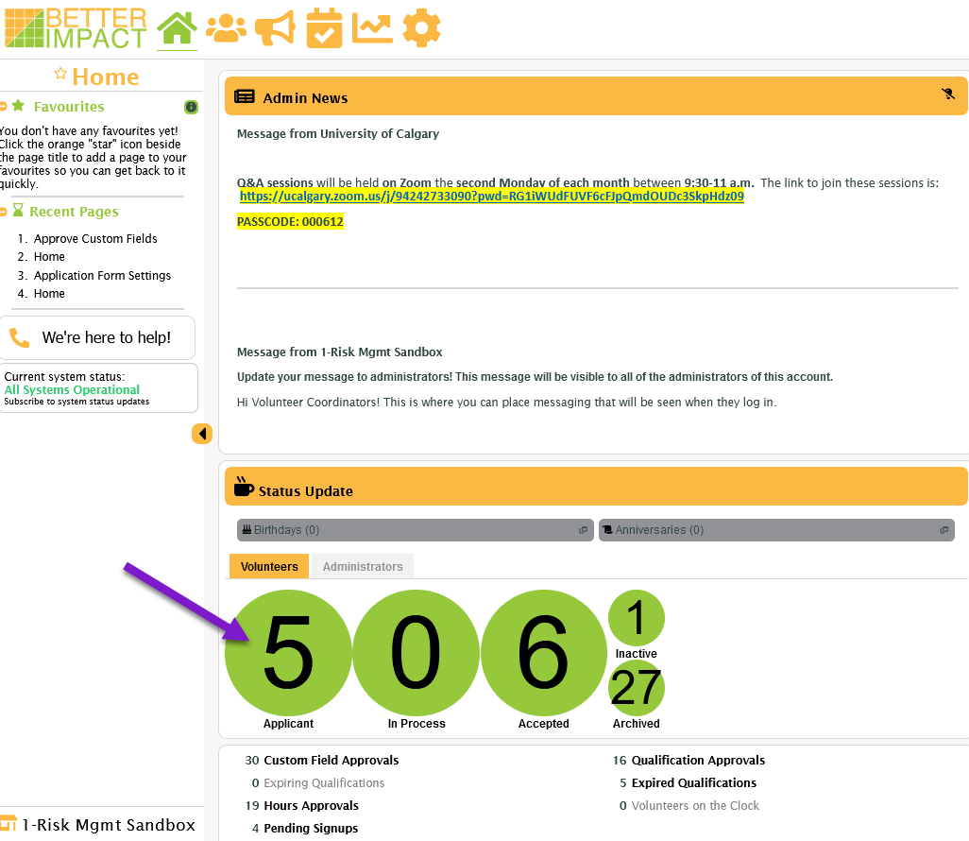

OHS Orientation completion
The OHS process is automated so does not require specific admin approval. Once the training is successfully completed, the system will automatically update the respective qualification on the volunteer’s profile. However, it is important that it is verified as completed before changing the applicant’s status to ACCEPTED.
Due to the nature of the software, once an individual completes this training, regardless of where they volunteered at UCalgary, they are not required or permitted to complete it again. For more details, refer to the page Volunteer OHS Orientation Process 2021.

Confirming completion:
- New applicants to UCalgary completing the OHS training for the first time
  - An email notification is sent to the administrator confirming completion - Fig. 2
    - AND the qualification status is updated to Complete
OR…
  - Existing or returning UCalgary volunteers who completed the training previously - Fig. 3
    - From the individual’s profile:
      - Under Qualifications tab
        - OHS Orientation 2021 = COMPLETE
Fig. 2 – Notification Email
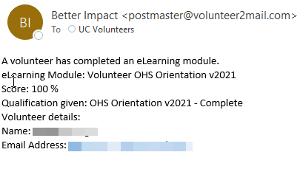
Fig. 3 – View profile
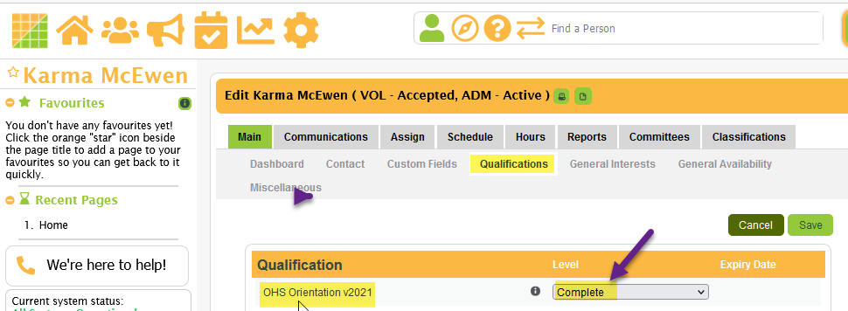

Updating Volunteers’ Status
After the applicant has fulfilled the abovementioned requirements, and any others that you require to meet your program requirements, their status must be manually changed to ACCEPTED. This can be done from the dashboard, their personal profile, or in bulk.
TIP: To help manage your applicants, Better Impact provides a status category of In Process – which can delineate those whose applications have been reviewed but still have requirements outstanding. This is an optional feature and must also be changed manually.
- From the Better Impact dashboard (home page) - Fig. 1:
  - Under Status Update
    - “Applicant” or “In Process”
- In Bulk - Fig. 4:
  - Under the People tab
    - Volunteers
      - Manage Applicants, OR
      - Bulk Volunteer Status Change - can be filtered as applicable
- From the individual’s profile – see Fig 5:
  - Miscellaneous
    - Volunteer
      - Status
        - SAVE
Fig. 4
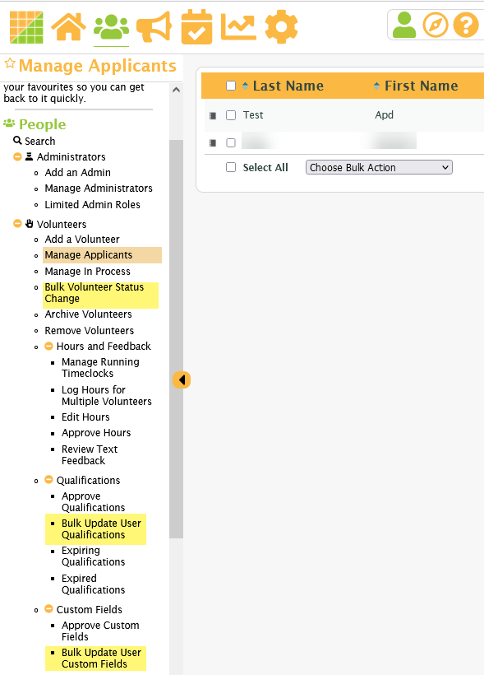
Fig. 5
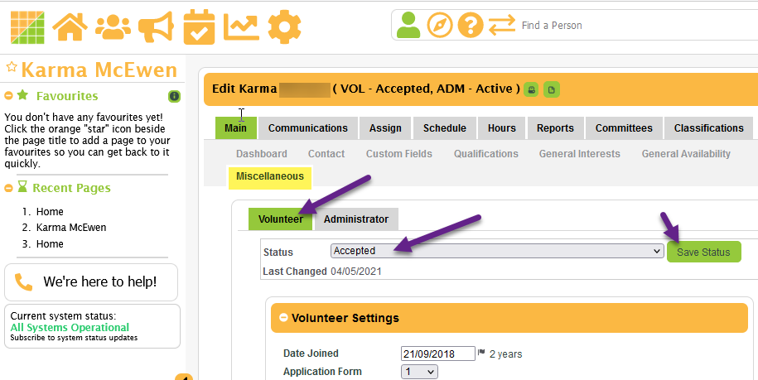

Creating Application Forms in Better Impact

Planning is essential. The more thought given to what you need to know about your volunteer applicants (application forms), and what your volunteers need to know about your opportunities (general interests and activities), the more successful you will be in matching volunteers to the appropriate opportunities.
Application Forms can only be edited by Dept Coordinators.

There are three possible application forms in Better Impact. Volunteer Form 1 is automatically set as the Default Application and is used, in most cases, as a general intake form. The following instructions apply to ALL versions of applications. Note: Department = Organization
To edit Application Forms, go to:
- Configuration menu –
  - Recruitment
  - Application Form Settings.

- Standard Contact information
  - is included on ALL applications;
  - is not displayed in the Application Form Settings;
  - and does not need to be specifically selected. These include:
- First and Last Names
- Legal First Name
- Address
- Email Address
- Phone
- Additional Information – collected on all applications to the University of Calgary
- Emergency Contact Name & Phone Numbers
- University Affiliation – Choices include Student, staff/faculty, public, degree graduates

Agreements & Acknowledgements – Volunteers
The following are required custom fields that appear once on ALL application versions. These fields are created at the Enterprise level and cannot be removed by the department. They require a checkbox response. The system will reject submission of the application form if volunteer does not accept these terms.
- I have read and understood the Waiver v2-Nov 2018 found in the description box (info icon) beside this field.
- I am age 18 or older.
- I will complete all Occupational Health & Safety requirements as directed by my volunteer coordinator.

Sections for Dept Coordinator to edit/update:
- New Volunteer Email Message field:
  - ALL APPLICATION FORMS should include messaging from the department about next steps but what is included is completely up to each department. It is useful to include:
    - information about the OHS training requirement (see below for possible wording and the link to the training); and
    - any other preliminary steps you wish your volunteers to take before being accepted to your program; and
    - any information the volunteer needs to participate in your program/event
- Application Complete Settings section - Dept Coordinators may update this information if the default messaging is not sufficient.
  - Enter a customized messaging acknowledging receipt of the application and any other information the applicant should know. Keep in mind this is a pop-up so keep it brief

Do NOT modify the following sections (unless otherwise noted):
* Items marked with an asterisk have already been included on all forms by the Enterprise Administrator at the time the department account was set up. Should these elements be inadvertently deleted or modified, please update as per the following instructions. Any items not identified by an asterisk must be performed by the Dept Coordinator.

- *Under General Settings: New volunteers require approval
- *Automatically send an email to new volunteers after the volunteer application form is filled out
  - This section should be updated to reflect your department’s practices (see notation under Sections for Dept Coordinators to edit/update above). It currently contains the following sample text for your reference:
    - “All University of Calgary volunteers must complete the Volunteer OHS Orientation.v2021. It can be accessed at Volunteer OHS Orientation.v2021 “

*All steps in Step One Settings are Required. These will be pre-filled with the following. Do NOT change this section unless the following information is missing or modified.
- *Under the Step One Settings section:
  - *Toggle off: “Show the birthdate field…”
  - *Select “Only show required contact information…” (optional setting)
- *Under Policy Settings
  - *Select “Require volunteers to accept your volunteer policies as the first step in filling out the volunteer application form”
  - *Do NOT select “Display Acceptance Policy in page” as this will unnecessarily display the waiver text in its entirety, on the login page.
  - *Under Policy Title include the text: RELEASE OF LIABILITY, WAIVER OF CLAIMS AND ASSUMPTION OF RISKS AGREEMENT
  - *Under “Policy Acceptance Checkbox Label” include the text (including the information about the waiver button: “I have read and understood the waiver below (click on Waiver button)”
  - *Under Policy Button Text enter: WAIVER
  - *Under Volunteer Policies Text include the “RELEASE OF LIABILITY, WAIVER OF CLAIMS AND ASSUMPTION OF RISKS AGREEMENT” text as provided in the Enterprise Document Library file RELEASE OF LIABILITY-applcopy.docx
Step Two Settings – All of these settings are OPTIONAL
- Step Two Settings section are for matching a volunteer’s interests, etc. to the opportunities your department has available. These settings have not been optimized by the University of Calgary so are best collected through the volunteer’s profile once they have been accepted as a volunteer for your department.
  - Show General Interests or Show General Availability
  - Classifications
  - General Availability & General Interests
  - Qualifications and/or Custom Fields - you may wish to add text to these Headers

- Required (this section will also be pre-filled and should only be edited if the following text is missing or modified):
  - *Under Override notice to complete application form text include the Privacy Statement as shown in the box on the following page – ensure that links in the statement are working
  - *Select Put this message inside a “notice” container.
  - *Do NOT select Also include this message at the bottom of the application form.

NOTE: Link to Privacy Policy: https://www.ucalgary.ca/legal-services/university-policies-procedures/privacy-policy
Privacy Statement
This information is collected under the authority of section 33(c) of the Freedom of Information and Protection of Privacy Act. It is required for the recruitment, scheduling, and associated reporting of volunteers and volunteer activities at the University of Calgary. For questions, please contact the FOIP Office at 403-210-8405 or at foip@ucalgary.ca or refer to the University of Calgary Privacy Policy.
- SAVE the form after editing and before reviewing interactive forms
  - Review the form by selecting one of the green buttons at the bottom of the screen to get the same view a volunteer applicant would see
- Generate Link button will create a link to be used on a website or other recruitment digital mediums to automatically connect users to this application form

- TIP: Use Volunteer Form 1 as your general intake application. Use Application Forms 2 and/or 3 for opportunities that require more extensive screening, previous experience, specialized skills, or to delineate one program from another.

For Help articles on functions in Better Impact, click on the icon in the Search bar (anywhere in Better Impact) and enter applicable search parameters.

Creating Activities in Better Impact

Activities are the specific roles/tasks performed by the volunteer at an event or within a program. Consider these in terms of a function that can be assigned and scheduled. Activities can be organized by the category (event/program) to which they are assigned.
**To meet reporting requirements, certain practices must be followed when creating activities, and will be identified as:
- Required Practices
- Recommended Best Practices
Step-by-step instructions for these functions are provided in the next pages and can also be accessed by going to Volunteer Impact Help which is also accessible from the SEARCH bar.
- Select the question mark before entering your query.

Add New Category
- “Category” in Better Impact refers to a collection of functions. As considerable reporting, including assigned shifts, can be run by Category, it is recommended that these are named as the specific name of the event/program (i.e., Convocation 2018, Peer Mentor Program 2019-2020, etc.). This reporting can be further broken down by Activity and shifts.
- Step-by-step instructions for Adding a New Category can be accessed from the Search bar.

  - Recommended Practices
    - The name of the Category can be specific to the event or program by including the date (i.e., Peer Helper Group Fall 2018)
    - The Description includes a brief description of the event or program, and any specific information an applicant needs to know before signing up for any associated activities
    - Considerable reporting, including assigned shifts, can be run by Category. This reporting can be further broken down by activity and shifts.

Add New Activity
- You may review the Better Impact step-by-step instructions Role Creation at the following link: https://www.betterimpact.com/volunteer-impact-help/activities-add-new/

  - Required Practices
    - To satisfy Occupational Health & Safety (OHS) requirements, the Description – pre-assigned box must include:
- a brief description of the task
- outline any physical demands or notable potential hazards
- include any specific skill/training requirements
- include the Document Library URL link to the activity-specific Hazard Assessment Control Form (HACF) as outlined in the document Occupational Health & Safety Requirements
    - Activity Report Group (under the Basic Info tab) - for WCB reporting purposes, the appropriate group should be selected from the dropdown list. Appendix B of the VRMS Admin Guide provides examples of activities that might be included in each group
    - Include the Feedback Field “Employee Volunteer Hours” on any activities where University of Calgary employees are recruited to assist during paid work hours.

  - Recommended Practices
    - The Visibility and Automation tab provides settings for the type of volunteer the activity will be Visible To. If Public is selected, the activity will be displayed on the University of Calgary’s Better Impact Search Page and visible to everyone, including the general public.
Note: Better Impact accounts must be configured to be visible/searchable by the Public. If you recruit from the general public, please contact the Enterprise Administrator to ensure your account is set up accordingly.
    - Classifications – (not generally used at UCalgary) are used to match potential volunteers to the department’s activities that meet their interests and availability. If a different Activity Classification is required than what is already available, contact the System Administrator at ucvolunt@ucalgary.ca to have it created.
    - Activity – should reflect the Activity Reporting Group previously selected. Select all that apply.
      - Suitability – targets the specific type of volunteer suitable to the task. If activity is for a specific program that requires a certain type of volunteer (i.e., only students, or only alumni, only 3rd year students, etc.) it should be indicated here.
      - Time Commitment – This section should reflect the activity’s expected hours
      - Duration Commitment – This section should reference the required program commitment. Some of the student volunteer positions require commitments of an entire term or several terms
      - Schedule – Matches volunteers’ weekly availability to the activity’s required days of attendance. These classifications cannot be changed or added to

- It is recommended that Activities are named generically and managed/organized by specifically named categories. For example: Sign-In Desk for UCalgary Strong Festival 2018; Orientation Leader for Orientation Week Fall 2018. However, there is no requirement that you organize your account this way.
- Templates can be created for frequently used activities or for events/programs that will repeat from one year to the next. The same roles/tasks can also be used for various categories (events) by copying or moving. For example: Sign-In Desk for the 50th Anniversary Celebrations; Sign-In Desk for UCalgary Festival; Sign-In Desk for Open House, etc. Refer to Activities: Move to a Different Category
NOTE: When copying or moving activities, remember to update the activity schedule and Active status to reflect the current event.

Create an Activity – Directions

Refer to the page Creating Activities in Better Impact for guidance and explanation of terms used in the following instructions.
- Configuration (gear icon)
- Activities
- Manage Activities

- First create (or select) a Category:
  - Select New Category (green button at bottom of screen)
  - Enter Category name
  - Enter Description. This can include information about your event/program, images, links to more information, etc.
  - Select Save
- Select New Activity (green button at bottom of screen)
  - Select Basic Info (default) tab (top menu bar)
    - Enter Activity name
    - Select Category from drop-down menu
    - Select Activity Report Group (these are created at the Enterprise level and align with our reporting categories for WCB purposes)
    - Select Application Form version (Default Application Form = Application 1)
    - Toggle Active, as applicable
    - Toggle Allow Hours Logging, as applicable
    - Toggle Auto Log Hours, as applicable (this setting should only be selected for large volume recruitment activities that require little oversight of attendance)
    - Toggle Backup List, as applicable
    - Enter in Description - pre-assigned a brief description of the required duties and expectations of the Activity – refer to Volunteer Hazard Assessments for specifics
    - If desired, enter in Description – post-assigned any information a volunteer should know once they have been assigned to the activity
    - If desired, enter in Internal Notes information necessary for other administrators – this is not a volunteer-viewable field
    - Select Next (green button at bottom of page)
  - Schedule tab
    - As applicable, select Recurring Pattern, Disjointed, One Time, Seasonal, No Schedule (green buttons at top of page)
    - If previously created, select from Choose a Template drop-down an applicable schedule OR
    - Enter schedule Pattern as per proffered fields based on the previously selected schedule pattern
    - These parameters can be saved as a template for future use by selecting Save this as a template (green button)
    - Enter Pattern Range (date/time period) as per proffered fields based on the previously selected schedule pattern
    - Select Check Shifts (green button) for a total number of shifts created
    - Select Next (green button at bottom of page)
  - Visibility and Automation tab – these selections will determine who can see the activity and will automate shift assignment and scheduling
    - Select parameters as applicable to your needs (self-explanatory) – for descriptions of settings see: https://support.betterimpact.com/volunteerimpacthelp/en/help-articles/add-new-activity-8/#step-3-visibility-and-automation
    - Select Next (green button at bottom of page)
- Additional optional features:
  - Qualifications tab
    - Select displayed Qualifications, as applicable to this Activity
Note: OHS Orientation.v2021 should be included on all activities
    - Select Next (green button at bottom of page)
  - Feedback Fields tab –
    - Include the Feedback Field “Employee Volunteer Hours” on ALL activities where UofC staff might volunteer during their regular working hours
    - Select the box beside any other Feedback Field applicable to this activity.
Note: **When a volunteer logs hours for the activity, the Feedback Field(s) will display and require a response
  - **Classifications tab – these selections are optional. They are search criteria for volunteers to filter opportunities based on their interests and availability
    - Select displayed Classifications under each tab (Activity, Suitability, Time Commitment, Duration Commitment, Schedule) as applicable to this Activity.
    - Select Next between tabs (green button at bottom of page)
**These criteria have not yet been optimized so may not result as expected.
- Select Save (green button at bottom of page)

Occupational Health and Safety Requirements

Under the OHS Act, Regulations and Code, volunteers are considered workers, and as the volunteers’ employer, the University of Calgary is responsible for providing safe working conditions and advising volunteers of their rights and responsibilities under the OHS Act. These processes are governed by the University’s Occupational Health and Safety Management System (OHSMS).
Environment, Health & Safety is the governing department for OHS requirements. For further information and interpretation of the OHS requirements, contact the Environment, Health, and Safety department at ucsafety@ucalgary.ca or phone 403-220-6345.

Occupational Health and Safety and Better Impact
To fulfill OHS requirements, follow the steps below:

Volunteer Coordinator OHS Orientation
Coordinators (Dept and Volunteer) are required to complete the Volunteer Coordinator OHS Orientation course (EHS036) (course ID – 1327) available in Enterprise Learning. Tracking is not required as the record is retained in PeopleSoft, but a custom field has been set up in Better Impact, should you wish to keep your own records.

Volunteer OHS Orientation
Before being approved to volunteer for the University, volunteers must complete the Volunteer OHS Orientation v2021 hosted as an eLearning module in Better Impact. This training can be accessed directly through a link generated in Better Impact (see instructions for Generating Links); or under the “Training” tab on the volunteer’s myImpactPage (MIP).

See Volunteer OHS Orientation Process 2021 for process steps.

Volunteer OHS Orientation Qualification
Once a volunteer successfully completes the OHS training:
- Their profile will automatically update the qualification “OHS Orientation v2021” with the notation “Complete” and
- An automated email notification is generated and sent to:
  - the Volunteer Coordinator, and
  - to UC’s Environment Health and Safety dept (OHS)
Volunteers are only required to do this training once. If they attempt to repeat it, they will get a message saying the training has already been done.

- Before changing a volunteer’s status to ACCEPTED, first confirm that the OHS Orientation v2021 qualification shows “Complete”
- Do NOT approve any volunteer until the Orientation has been completed and the qualification is updated on their Better Impact profile

Volunteer Hazard Assessment
To assist in provisioning the activity-specific Volunteer Hazard Assessment, include it in Better Impact by following the steps below.
**For assistance with determining the necessary frequency and preparation of the Volunteer Hazard Assessments for specific volunteer activities, please contact the Environment, Health & Safety department at ucsafety@ucalgary.ca or phone 403-220-6345.
  - It is important that the steps below are performed in the same order as outlined here:

- BEFORE creating an Activity in Better Impact, prepare the Volunteer Hazard Assessment form available on the EHS website (for convenience, this form is also available in the Enterprise Document Library)
- Prepare the Hazard Assessment specific to your activity
- Upload the prepared Volunteer Hazard Assessment to your department’s Document Library
- Once Saved, click on the options icon and select “Generate a Link”. Copy this link for future use
- Create the activity in Better Impact:
- In the Description Field of the activity include any pertinent expectations about the activity.
- Under the “Basic Info tab include a similar statement in the Description – pre-assigned box:
“To be considered for this activity you are required to complete the Volunteer OHS Orientation, if you have not already, and review the Volunteer Hazard Assessment for this activity. This document will be presented to you for signature before starting to volunteer for us.”
(Include a link to the previously prepared Hazard Assessment).
**Note: Prepared activity-specific Hazard Assessment Forms can be stored in the Document Library but signed versions should be retained in your department’s network folders.
Complete any remaining OHS requirements as directed in the Volunteer Coordinator OHS Orientation (Course ID 1327)

Volunteer OHS Orientation Process 2021

All volunteers, new AND existing, are required to complete the Volunteer OHS Orientation v2021 version of the OHS Orientation, regardless of any other OHS training they have done in the past.
- Volunteer coordinators are responsible for ensuring volunteers fulfill this OHS requirement. No volunteer should be approved for assignment before completing this step.

Steps for Coordinators:

OHS - New Applicants:
- Applicants are required to agree to completing any OHS requirements as directed by their coordinator.
  - This is presented as a statement on the application forms and requires agreement by selecting a checkbox.
  - Application form will be rejected by the system if applicant does not agree to the OHS terms
- A link to Volunteer OHS Orientation v2021 eLearning module should be provided in the New Applicant automated email for newly submitted application forms (refer to document Creating Application Forms in Better Impact)
  - This link can be generated under the:
    - Configuration icon
    - Recruitment (left-sidebar menu)
    - then Links for Website
    - choose eLearning module (see screenshot)
    - select from dropdown Volunteer OHS Orientation v2021
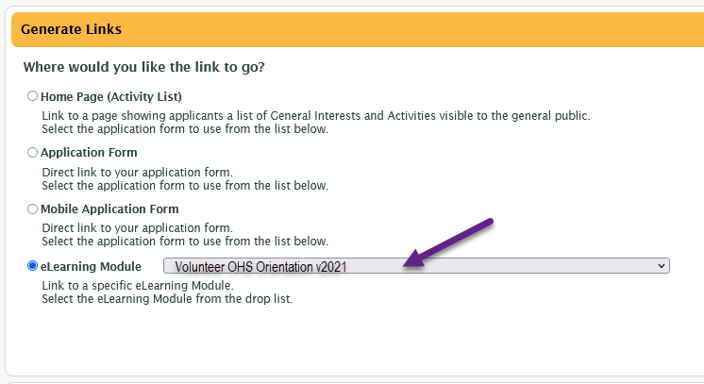

OHS - Applicable to ALL Volunteers:
The OHS training module is also permanently available on myImpactPage.com (under the Training tab) for completing it initially, or to review the content and results later. The document Directions to Access Volunteer OHS provides directions for volunteers to access the training. This file is made available to volunteers under Files on the Home page of your account’s myImpactPage.
- Direct volunteers to the volunteer portal, myImpactPage.com
  - My Profile menu
  - Training
  - Volunteer OHS Orientation v2021

OHS Completions:
            - Upon successful completion of the OHS training, Coordinators should receive an automated email notification that the requirement has been met. (This notification is dependent on your administrator notifications settings)
              - This notice is also sent directly to our OHS department for their records
              - Departments are not required to retain the notifications in their files
            - The corresponding qualification named, OHS Orientation v2021, automatically updates on the volunteer’s profile to “Complete”
              - Volunteers must achieve 100% to update the Qualification to “Complete” and are able to re-try as many times as needed

OHS Orientation v2021 Qualification:
  - This qualification updates automatically in response to a volunteer successfully completing the OHS eLearning module.
  - It follows the volunteer throughout the University, so they will not have to take this course again, regardless of which, or how many, departments/programs/events they volunteer with.
  - If you do not receive a notification of completion, check this qualification’s status before following up with the volunteer/applicant. They may have completed the training while volunteering with another UCalgary department

Checking for prior completions of the OHS training
To confirm the OHS requirement has been fulfilled by an individual, go to:
    - applicant’s profile (use Search bar)
    - Qualifications tab
      - “Complete” should be recorded in the OHS Orientation v2021 field
      - If the field is blank, the volunteer has NOT completed the training

To review that the OHS requirement has been fulfilled by multiple volunteers, go to:
    - People icon
    - Volunteers’ menu
    - Qualifications
      - Bulk Update User Qualifications
        - Filter search, as applicable

departments are expected to follow up with their volunteers if this version of the OHS Orientation has not yet been completed. Departments should not permit a volunteer to continue to assignment until they fulfill this requirement.

Volunteer Hours: Logging, Approving, Reporting

Logging Hours
- Required Practice:
Volunteers’ Hours must be recorded (logged) and subsequently approved by volunteer coordinators. They may be recorded:
- by the volunteer
- entered by the Coordinator
- auto logged
See the directions for Create an Activity – directions document for the applicable settings to permit volunteers to record their own hours; or to automatically log hours.
Step-by-step instructions for the functions listed below can be accessed through the program by clicking on the question mark in the Search bar and entering your query.
- Coordinator Logs Hours
- Volunteer Logs Hours
- Approving Hours
Auto-Logging Hours
To set up auto-logging hours, refer to the instructions for Auto Log Hours Activity Settings. Auto-logging is not recommended as the system will credit any volunteer that is scheduled, even if they did not attend.

Approving Hours
- Required Practice
    - Volunteers’ hours must be approved by a Coordinator
Note: If there are hours logged by volunteers, but not yet approved, the Hours Approvals on the Home page dashboard under Status Update.

Hours Reporting
The Enterprise Administrator reports volunteers’ hours to Payroll for subsequent reporting to WCB.
- Required Practice
- All hours must be recorded and approved by Coordinators not later than January 15th or as directed by the Enterprise Administrator. To ensure all logged hours are up to date and approved, you will receive reminders just before and just after the Christmas break.

Managing UC Volunteers – Legislative Components in Better Impact

There are several legislative requirements governing the engagement of volunteers at the University of Calgary. Many of these requirements can be managed within the Better Impact system. It is important that department coordinators are familiar with these requirements and the steps necessary to meet compliance.
Note: The Better Impact system has a feature called Document Library. Updated versions of any documents referenced in this document can be found in the Enterprise Document Library; on the Risk Management & Insurance Website; or the governing department’s website.

Definition of a University of Calgary Volunteer
Individuals who, with or without special training, provide services or assistance to the University without payment of fees, wages, or salary, and without any expectation of any kind of compensation (except travel costs or meal expenses).
Volunteers must be:
- over 18 years old, and either:
- have Canadian Citizenship or Permanent Resident Status in Canada; or are
- a current international student enrolled full time at the University of Calgary and hold a Study Permit. In this case, the volunteer activities must be short-term and incidental to their student work.

Occupational Health and Safety (OHS)
Under the Alberta OHS Act, Regulations and Code, volunteers are considered workers and entitled to the same safety provisions as employees at the University of Calgary. These processes are governed by the University’s Occupational Health and Safety Management System (OHSMS). The VRM system includes processes to help track the OHS requirements for volunteers and Volunteer Coordinators; and to facilitate access to prepared Hazard Assessments.
Review the page Occupational Health & Safety Requirements for more information about the responsibilities of Volunteer Coordinators for incorporating OHS elements into the VRM processes, including:
- completing the Volunteer Coordinator OHS Orientation; (course ID 1327)
- directing volunteers to complete the Volunteer OHS Orientation hosted as an eLearning module in Better Impact
- and, specific to each activity, the preparation and retention of Volunteer Hazard Assessments

Workers Compensation (WCB)
To meet the terms of the University’s WCB coverage, volunteers must be registered, and the dates of their activities and hours worked recorded. These requirements are facilitated through the VRM system and recorded in Better Impact. Specifics are included in the instructions for Volunteers’ Hours: Logging, Approving, and Reporting

Freedom of Information and Protection of Privacy Act (FOIP)
The types of information that can be collected about individuals is determined by the FOIP Act and governed at the University by the Privacy Office http://www.ucalgary.ca/legal-services/access-information-privacy.
To meet compliance when engaging volunteers at the University, the following requirements must be met:
- All Department Administrators and Volunteer Coordinators with access to Better Impact data must sign an Oath of Confidentiality
- A Privacy Statement must be placed on all Better Impact applications – See Creating Application forms in Better Impact for required placement and wording
- An opt-out disclaimer must be included in all electronic communications sent to volunteers.
- Photo Consent Filming and Photography forms must be signed by volunteers as outlined in the University’s Privacy Policy https://www.ucalgary.ca/policies/files/policies/privacy-policy-2011.pdf
- Information collected from a volunteer must specifically align with the purpose of its collection as it applies to the volunteer opportunity. Guidelines for, and examples of, acceptable data collection can be acquired from the Privacy Office.
- Email communications should be cc’d to the sender’s ucalgary.ca address and include the names of those the email was sent to. Volunteers’ profiles and associated data must be retained within Better Impact system for a minimum of twelve (12) years as per the University’s Master Records Retention Rule GV-610-Risk Management.

Legal Liability Compliance
Release of Liability, Waiver of Claims and Assumption of Risks Agreement - Volunteers are required to accept the agreement before engaging in volunteer activities at the University. This agreement is incorporated in two places in Better Impact. To insert these statements, they must be added into the Step One: Policy Statement section of the application form at the department level. Additionally, a Custom Field created at the Enterprise level is included automatically on every application. To ensure the volunteer has accepted the agreement, Administrator’s must approve the Custom Field before the applicant can be accepted as a University volunteer. This record is included on the volunteer’s Better Impact profile, should they wish to reference it later.
For a current version of the Release of Liability, Waiver of Claims and Assumption of Risks Agreement go to the Enterprise Document Library in Better Impact, or the Risk Management & Insurance website

Human Resources
Occasionally, a role is better filled as a paid position rather than a volunteer position. If in doubt, departments should check with their HR representative for clarity and approval.

VRMS Administrators’ Roles and Responsibilities

Note: References to “Volunteer Coordinators” refers to any administrator that is involved in the management of volunteers. Dept Coordinators have additional responsibilities and access in Better Impact but are still considered “volunteer coordinators” for training and required documentation purposes.
In addition to the Enterprise/System Administrator, there are two levels of administrator access in the University’s VRM system. Each role has different responsibilities and levels of functionality in the Better Impact system. The following describes the expectations of each role:

Enterprise:

Enterprise/System Administrator:
- Staff member of the Risk Management & Insurance department
- Administrative liaison between the University of Calgary and the online system provider, Better Impact
- Liaison between the department accounts and the University’s enterprise account
- Manages the assignment of Better Impact accounts to university faculties/departments/programs
- Authorizes, adds, and removes Department Coordinators’ access to the departments’ Better Impact accounts
- Authorizes, adds, and removes Volunteer Coordinators’ access to the department’s Better Impact account
- Ensures Oaths of Confidentiality are completed and on file
- Ensures Volunteer Coordinator OHS Orientation Certificate of Completions are submitted and on file
- Coordinates processes for meeting regulatory compliance
- Develops and facilitates training for administrators
- Coordinates processes for reporting/auditing requirements
- Creates enterprise Qualifications and Custom fields
- Creates department Qualifications and Custom Fields
- General support for Dept Admins

Department (Organization) Account:

Dept Coordinator:
- The primary contact for the department, and liaison to the Enterprise/System administrator
- Oversees/trains Volunteer Coordinators
- Obtains and forwards Volunteer Coordinators’ Oaths of Confidentiality
- Advises and confirms Volunteer Coordinators complete the Volunteer Coordinator OHS Orientation
- Communicate legislative compliance requirements to Volunteer Coordinators
- Develops processes for OHS requirements including, but not limited to, the Volunteer OHS Orientation and Hazard Assessments
- Develops processes for retaining historical data and documentation for audit, as per respective University policies
- Configures department’s Better Impact account – contact information, customizing/branding, application form development, etc.
- Performs functions necessary to managing volunteers, as determined by system requirements and department's processes, including:
  - Recruiting
  - Approving custom fields and qualifications as part of the applicant approval process
  - Updating volunteers’ status, as applicable (i.e., accepted, in process, inactive, archive)
  - Creating activities
  - Communicating with volunteers
  - Assigning volunteers to activities
  - Scheduling shifts
  - Logging and/or approving logged hours
  - Ensuring regulatory compliance elements are included in Better Impact (as per instructions from Enterprise)
  - Ensuring volunteers agree to and complete waivers; Volunteer OHS Orientation, and any other required documentation
  - Provisioning site-specific OHS Volunteer Hazard Assessments forms
  - Provisioning volunteers with any necessary training to perform the role
  - Reviewing site-specific Hazard Assessments with volunteers and obtaining signatures on the Volunteer Hazard Assessments forms
  - Ensuring all OHS requirements are met
  - Retaining signed Hazard Assessments and other OHS documentation for audit/reporting

Volunteer Coordinator (VC)
- Performs functions necessary to managing volunteers, as determined by system requirements and department's processes, including:
  - Recruiting
  - Approving custom fields and qualifications as part of the applicant approval process
  - Updating volunteers’ status, as applicable (I.e., accepted, in process, inactive, archive)
  - Creating activities
  - Communicating with volunteers
  - Assigning volunteers to activities
  - Scheduling shifts
  - Logging and/or approving logged hours
  - Ensuring regulatory compliance elements are included in Better Impact (as per instructions from Enterprise)
  - Ensuring volunteers agree to and complete waivers; Volunteer OHS Orientation, and any other required documentation
  - Provisioning site-specific OHS Volunteer Hazard Assessments forms
  - Provisioning volunteers with any necessary training to perform the role
  - Reviewing site-specific Hazard Assessments with volunteers and obtaining signatures on the Volunteer Hazard Assessments forms
  - Ensuring all OHS requirements are met
  - Retaining signed Hazard Assessments and other OHS documentation for audit/reporting

